Candidate Id: 2380155

Name : Bharath Magesh

Assignment No : 01

1)Write a Java program to get the character at the given index within the String

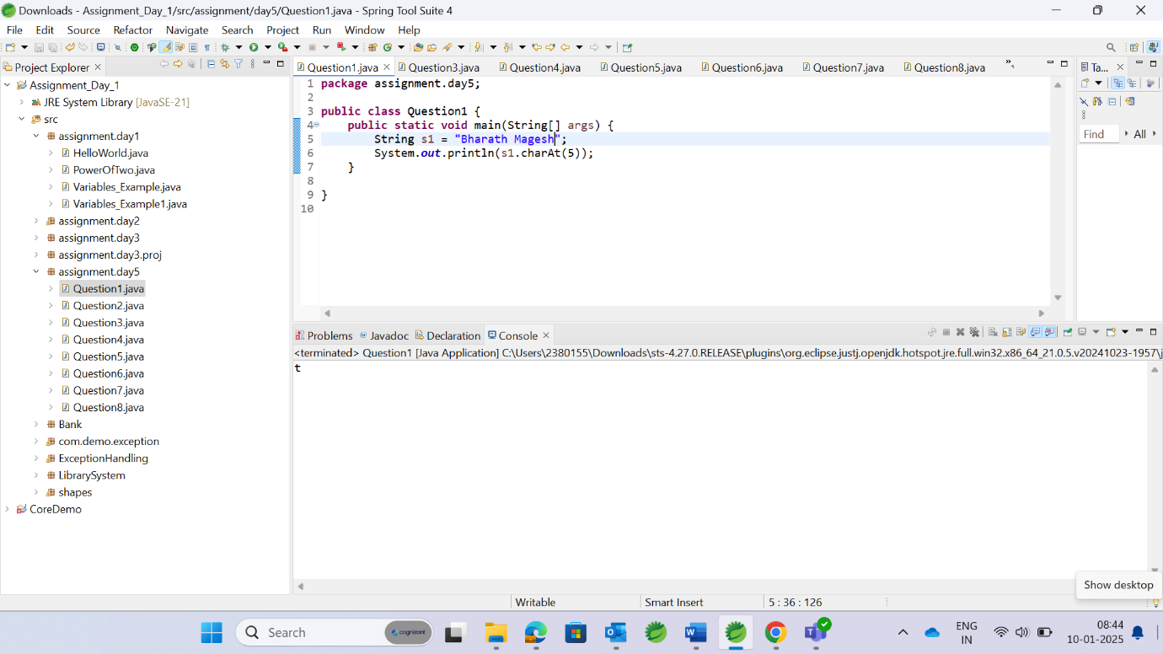

2)Write a Java program to convert all the words first letter into capital for given String? (String s=”java standard edition”)

3)Write a Java program to test if a given string contains the specified sequence of char values….match() “welcome to carrertuner”

4)Write a Java program to check whether a given string ends with the contents of another string (endsWith())

5)Count the number of words present in the given string?

6)Print the capital letters from string?

7)Convert the second occurrence of ‘ l ’ into capital from “bvrit college”. lastIndexOf(‘l’)==index-9→toUppercase

8)Convert the word from small letter to capital letter word in given String ?

String s =”b.v.raju college” //convert raju into capital.  
